Example 1: Define a function that takes an argument. Call the function. Identify what code is the argument and what code is the parameter.
Explanation:
Let’s talk about definition of parameter: “A name used inside a function to refer to the value passed as an argument” (Downey, 2015). It means, in our function, name is a parameter. Argument is “a value provided to a function when the function is called. This value is assigned to the corresponding parameter in the function” (Downey, 2015). ‘Mama’ inside the function call(‘Mama’) is an argument.

Example 2: Call your function from Example 1 three times with different kinds of arguments: a value, a variable, and an expression. Identify which kind of argument is which.
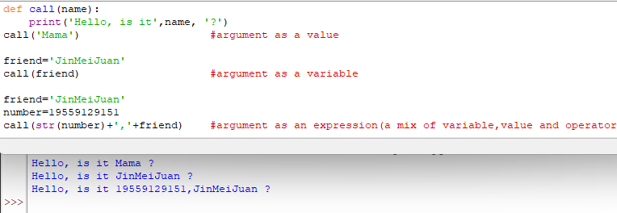
Explanation of which kind of argument is which is in the screenshot in the form of code comments within the code.

Example 3: Construct a function with a local variable. Show what happens when you try to use that variable outside the function. Explain the results.
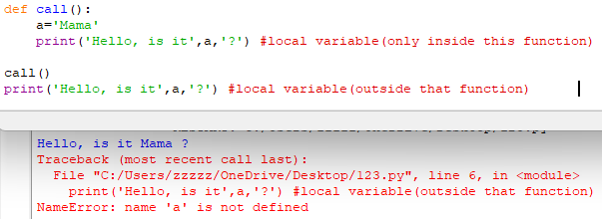
As Think Python explains: “A local variable can only be used inside its function” (Downey, 2015). Once the function finishes its work, the variable dissapears, and that’s why when we try to use ‘a’ outside the function, Python cannot find it.

Example 4: Construct a function that takes an argument. Give the function parameter a unique name. Show what happens when you try to use that parameter name outside the function. Explain the results.
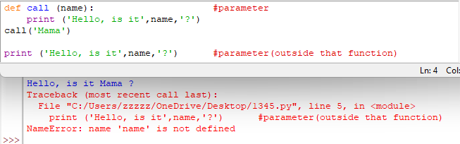
Parameter of the function behaves exactly like a local variable. It can only work inside the function.

Example 5: Show what happens when a variable defined outside a function has the same name as a local variable inside a function. Explain what happens to the value of each variable as the program runs.
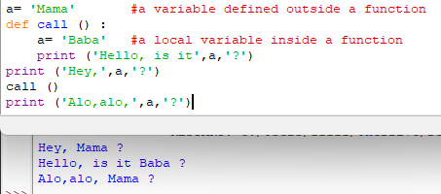
When Python prints a first result, it uses a variable defined outside the function, same as in the third result. In the second result, Python uses a local variable. It happens because Python keeps that for different things. A local variable cannot replace a variable outside the function.
The variable outside the function "Mama" exists throughout the whole program,while inside the function, the variable 'Baba' is a separate local variable that temporarily hides the global one. Now outside the function, only the global a is accessible.

